Equity Action Plan 2025-28

1

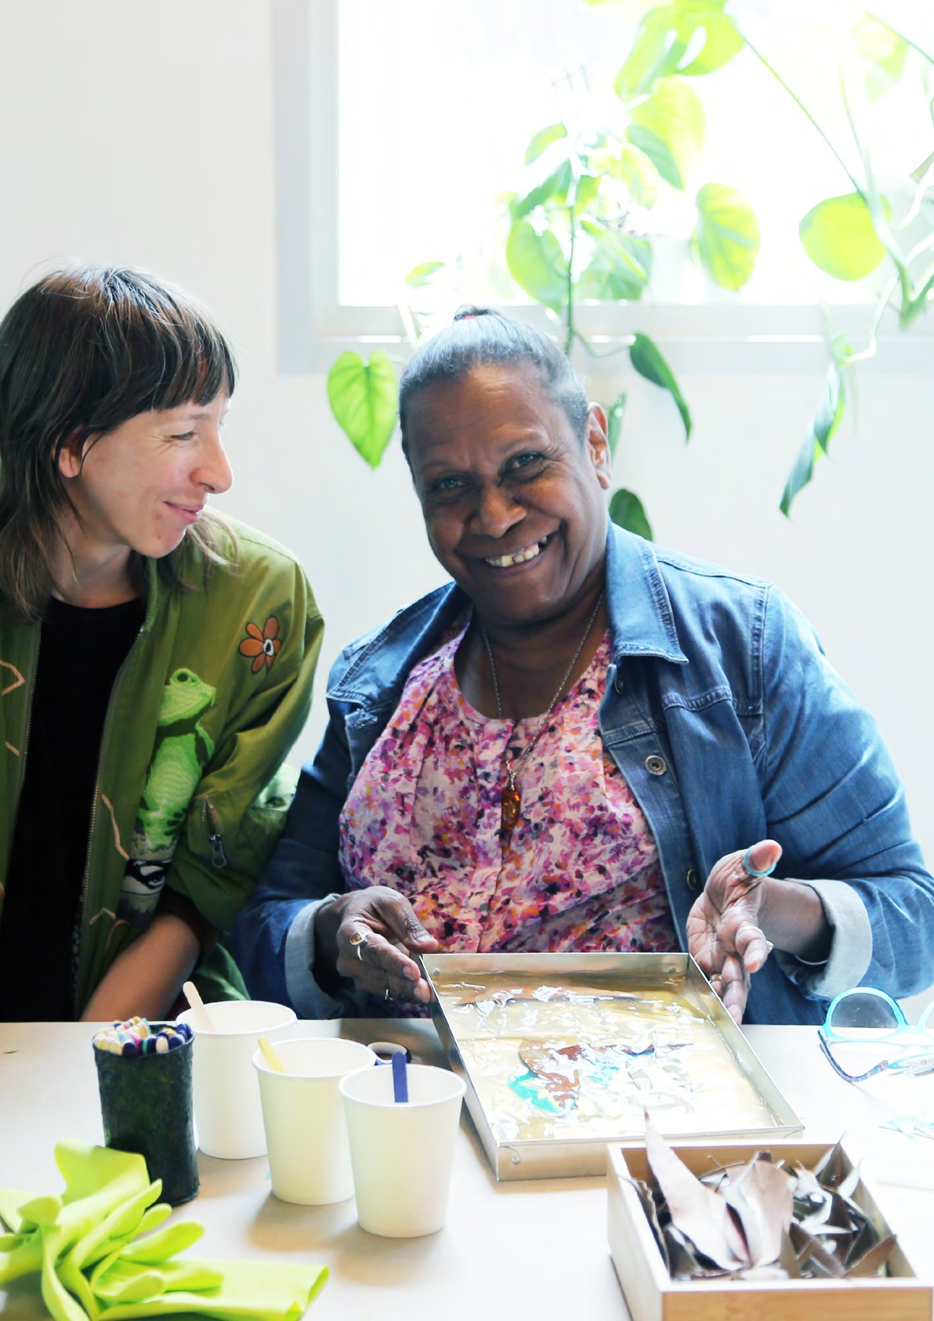

**Equity Action Plan 2025-28**

**Public Galleries Association** Victoria

**PG**

**A** V

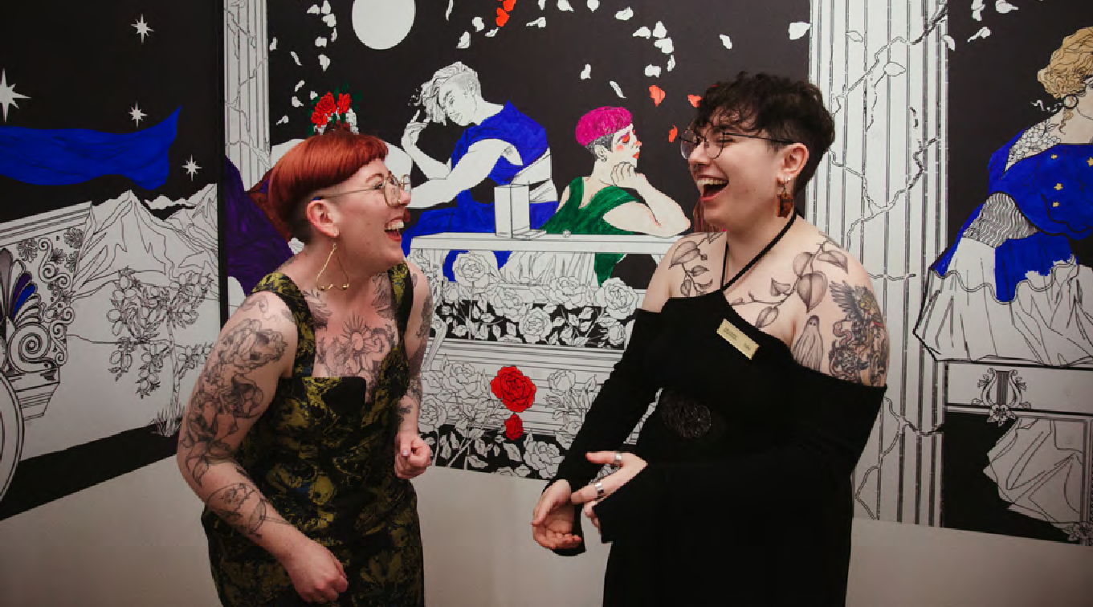

# ACKNOWLEDGEMENT OF TRADITIONAL OWNERS

Public Galleries Association of Victoria (PGAV) acknowledges the Wurundjeri Woi-Wurrung people of the Kulin Nation as the Traditional Owners of the lands where our office is located, and all Traditional Owners of country throughout Victoria and Australia. We recognise Aboriginal and Torres Strait Islander peoples’ enduring traditions and continuing creative cultures. We pay our respect to Elders past, present and emerging.

# PGAV

Public Galleries Association of Victoria (PGAV) is the peak body for public galleries in Victoria. We represent over 65 galleries, including 19 regional galleries, who together reach 5.3 million visitors annually.

# OUR MISSION

Is to build and strengthen the capacity of public galleries in Victoria to deliver valuable cultural, social and economic returns to their communities. To achieve this mission we act as a broker between our members, the three-tiers of government, the private and philanthropic sectors, education and research institutions, the media and the community.

# OUR VISION

Is a vibrant, cohesive, professional network of public galleries across Victoria that deliver inspiring visual art experiences which are relevant and accessible to the whole community.





Images:

Cover: Jessie French and Gail Mabo host a workshop in the MUMA Education Lab as part of the exhibition *Rivermouth*, Monash University Museum of Art (MUMA), 2023. Photo: MUMA.

Above: Mayticks, Artist and Tobias Fulton, Project Lead in the *Greek Love Outside the Lines* exhibition, Hellenic Museum, 2023. Photo by Harper St Clair.

PGAV is supported by the Victorian Government through Creative Victoria and receives significant in-kind support from the National Gallery of Victoria.

**Equity Action**

**Plan 2025-28**

# INTRODUCTION

**Public Galleries Association of Victoria (PGAV)** is the peak body for the public gallery sector in Victoria. We represent over 65 galleries and art museums, including 19 regional galleries. For over 40 years PGAV has been supporting the development of

the sector, advocating on behalf of the sector, and promoting the sector to new and increasingly diverse audiences.

Public galleries exhibit, collect, conserve and promote engagement with the visual arts. Through their exhibitions and programs, public galleries provide audiences across Victoria’s suburbs and regions with unique opportunities to come together and actively engage with art and artists. Each year more than 5.3 million people visit a public gallery to see the work of over 7,000 visual artists and take part in more than 4,100 public programs.

Public galleries have a long history of presenting and collecting the work of First Nations artists, however only 13% of the sector employs Aboriginal and Torres Strait Islander staff. Similarly, Victoria’s public galleries regularly showcase work by women, Culturally and Linguistically Diverse (CALD), migrant,

LGBTQIA+, Deaf and disabled artists, but more can be done to ensure galleries reflect the diversity of the communities they serve and are accessible to all.

Diversity Arts Australia’s report *Shifting the Balance* reveals that CALD leadership in the Australian creative sector is low. With 58% of the Australian population identifying as having an Anglo Celtic cultural background, this group disproportionately makes up 87% of leadership roles in the Australian non-profit cultural sector. In relation to public galleries, the report shows 65% of the museum and heritage sector and 45% of the visual arts sector had no CALD leadership. The report notes that while creative organisations are committed to improving cultural diversity, this is unlikely to change without CALD people in leadership1.

As the industry peak body, PGAV has a leading role to play in addressing barriers and ensuring equitable access to public galleries across Victoria. Through this Equity Action Plan we will increase the diversity of people who are employed and lead our galleries,

as well as those who feel welcome to exhibit, visit and engage with Victoria’s public galleries.

### Process

This Plan is the result of PGAV taking part in the *Fair Play: Regional Victoria* program throughout 2023 –

delivered by Diversity Arts Australia and funded by Creative Victoria. An equity and inclusion audit of PGAV identified our commitment to Justice, Equity, Diversity and Inclusion (JEDI), with strengths in First Nations programming and engagement. Areas

of improvement include PGAV policies, training and leadership for the sector, underpinned by greater consultation with CALD, Deaf and disabled communities.

### Next four years

This Plan details PGAV’s goals over the next four years across the following key areas: **Governance**

- policy, leadership, employment; **Capacity Building** – training and programming; **Engagement** – community consultation, marketing and promotion. Each goal outlines short and long-term actions, with outcomes and evaluation measures. The goals will be embedded into [***PGAV’s Strategic Plan 2022-25***](https://pgav.org.au/PGAV-Strategic-Plan-2022-2025~7050), to ensure equity is progressed and the public gallery sector in Victoria is truly welcoming and accessible to all.

### Evaluation & Review

This is a living document and we will update and report on our progress biannually. Bringing this plan to life

will ensure PGAV and public galleries in Victoria better reflect the diversity of the artists and communities we serve.

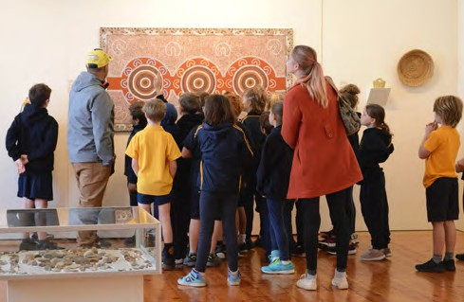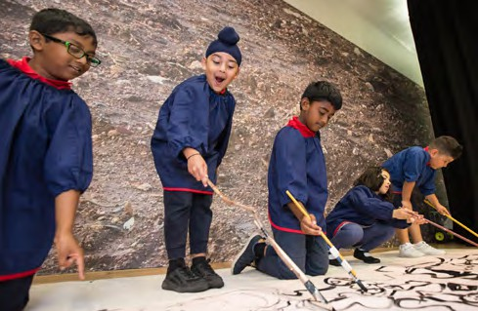

Images: 1. School visit to East Gippsland Art Gallery to see *Southeast NOW*, 2022. Artwork: Alice Pepper, *Past, Present, Future*, Acrylic on canvas.

1. Students at an education program associated with the exhibition *Tree Story* at Monash University Museum of Art, 2019. Photo: Rodney Dekker.

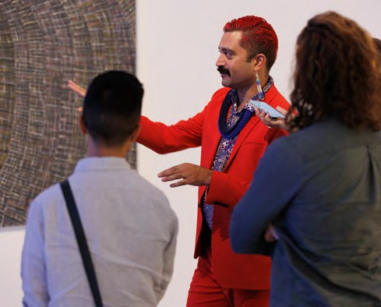

Image: Curator Dr Léuli Eshrāghi at the launch of the TarraWarra Biennial 2023: *ua usiusi faʻavaʻasavili*, TarraWarra Museum of Art, 2023. Photo: James Henry Photography.

# VICTORIA’S DEMOGRAPHICS

Australian Bureau of Statistics 2021 Census tells us:

* + 1% of Victoria’s population are Aboriginal and/ or Torres Strait Islander. The Local Government

Areas with the largest Aboriginal and Torres Strait Islander population are Greater Geelong (5.4% of state population), Greater Bendigo (4.2%), Greater Shepparton (4.1%), Mildura (4.0%), Wyndham

(3.8%), Casey (3.6%) and Whittlesea (3.5%).

* + 30% of Victoria’s population were born overseas. Most common places of birth are India (4%), England (2.7%), China (2.6%) and New Zealand (1.5%).
  + 27.6% of Victorians speak a language other than English at home. Most common languages are Mandarin (3.4%), Vietnamese (1.8%), Greek (1.6%)

and Punjabi (1.6%).

* + 17% of Victorians identify as a person with disability. 77% of people with a disability have a physical disability2.
  + 5.2% of Victoria’s adult population identify as LGBTIQA+3.

# TERMINOLOGY

In this Equity Action Plan, the following terms and acronyms are used with the respective meanings:

**Culturally and Linguistically Diverse (CALD)**: in line with the Victorian Government, PGAV defines CALD as people of non-English speaking background,

**Disability:** in line with the *Disability Discrimination Act 1992 (Cwlth)*, PGAV recognises the definition of disability as including physical, intellectual, psychiatric, sensory, neurological and learning

disabilities. Disability can be permanent or temporary, visible or invisible.

**Deaf:** refers to people who were born Deaf, or became Deaf, and who may use Auslan sign language to communicate.

**LGBTIQA+**: in line with the Victorian Government, PGAV uses the acronym to mean Lesbian, Gay, Bisexual, Trans and gender diverse, Intersex, Queer and Asexual. This is an inclusive umbrella abbreviation of diverse sexualities, genders and sex characteristics and recognises legal and social marginalisation on the basis of dominant social norms around sex, gender and sexuality.

**JEDI:** Justice, Equity, Diversity and Inclusion.

# PRIORITY STATEMENT

Over the next four years, PGAV will build our capacity to be a leader in the areas of Justice, Equity, Diversity and Inclusion (JEDI). We will better understand

and promote the equity activities of our members, strengthening and broadening their capacity to be accessible to the whole community through training and support. We will evaluate equity work undertaken in the sector with ongoing community consultation. And we will work to build a broader audience for Victoria’s public galleries through a diverse approach to marketing and communications.

# FOUR YEAR PLAN

The next four years will see PGAV deliver on a range of short-term and long-term actions to achieve the goals required to ensure Victoria’s public galleries are welcoming and accessible to the whole community.

### Acronyms used in the four year plan:

AAV: Arts Access Victoria

ACNC: Australian Charities and Not-for-profits

Commission

AGM: Annual General Meeting CAV: Consumer Affairs Victoria

CCD: Community Cultural Development DARTs: Diversity Arts Australia

KHT: Koorie Heritage Trust MAV: Multicultural Arts Victoria

MRCs: Multicultural Resource Centres

as well as people born outside of Australia and

whose first language is not English. While CALD is

regularly used in government and policy circles and is a requirement for many of the funders we report to, we recognise that the definition does not always accurately reflect people and communities who face ongoing discrimination on the basis of their cultural background.

**INTRODUCTION ENDNOTES**

1. Diversity Arts Australia, BYP Group and Western Sydney University (2019), *Shifting the Balance: Cultural Diversity in Leadership Within Australian Arts, Screen and Creative Sectors*, pg4.
2. [https://www.vic.gov.au/state-disability-plan/about-plan/about-people-](https://www.vic.gov.au/state-disability-plan/about-plan/about-people-disability) [disability](https://www.vic.gov.au/state-disability-plan/about-plan/about-people-disability)
3. [https://www.safercare.vic.gov.au/sites/default/files/2020-09/The-health-](https://www.safercare.vic.gov.au/sites/default/files/2020-09/The-health-and-wellbeing-of-the-LGBTIQ-) [and-wellbeing-of-the-LGBTIQ-population-in-Victoria.pdf](https://www.safercare.vic.gov.au/sites/default/files/2020-09/The-health-and-wellbeing-of-the-LGBTIQ-)

## GOVERNANCE: policy, leadership and employment Governance Goal 1: Policy

|  |  |  |  |  |
| --- | --- | --- | --- | --- |
| **SHORT-TERM: develop a JEDI statement or pledge** | | | | |
| **Action** | **Responsibility** | **Timeline** | **Resourcing** | **Consultation** |
| Research JEDI statements and develop a statement that meets PGAV’s mission. Seek endorsement from diverse communities. | Executive Officer | March 2025 |  | AAV, DARTs, KHT, MAV |
| Seek ratification from PGAV Board and inte- grate into Strategic Plan goals and KPIs | Executive Officer, Board | May 2025 |  |  |
| Promote statement on website and via com- ms. | Executive Officer, Comms Officer | June 2025 |  |  |
| **Outcomes**   * PGAV has a JEDI statement which is endorsed by diverse communities. * JEDI statement shared with sector and wider community. | | | | |
| **Evaluation**   * Member Survey – ask if members are aware of PGAV JEDI statement. | | | | |
| **LONG-TERM: JEDI statement integrated into PGAV Rules of Association** | | | | |
| **Action** | **Responsibility** | **Timeline** | **Resourcing** | **Consultation** |
| Draft JEDI statement within PGAV Rules.  Ratified by Board. | PGAV Legal Rep,  Board | March 2026 |  |  |
| Take to members for approval at AGM. | Executive Officer | May 2026 |  |  |
| Rules updated with CAV and ACNC, published  on PGAV website. | Executive Officer | June 2026 |  |  |
| Review JEDI statement every 2 years, devel- op specific Action Plans as needed (ie RAP,  DAP) | Executive Officer, Board | March 2028 |  | AAV, DARTs, KHT, MAV |
| **Outcomes**   * JEDI statement embedded in governing documents, ensuring longevity. * PGAV programming shifts in response to JEDI statement. * PGAV Member programming shifts in response to JEDI statement. | | | | |
| **Evaluation**   * Comparing PGAV programming from previous years to now. * Comparing PGAV Members programming from previous years to now. | | | | |

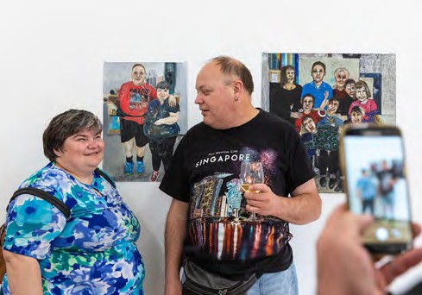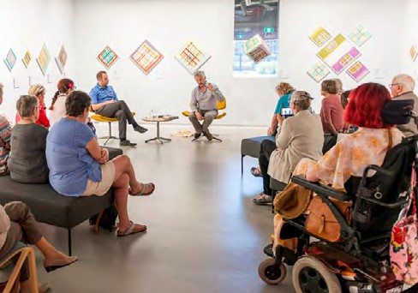

Image: Artists Monica Lazzari and Chris Mason at the *Tones of Home*

exhibition opening, Arts Project Australia, 2023. Photo: Janelle Low.

Image: Gallery Director Simon Gregg and artist Matthew Thomas, *First Fridays Conversation Series*, Gippsland Art Gallery, 2019.

## Governance Goal 2: Leadership

|  |  |  |  |  |
| --- | --- | --- | --- | --- |
| **SHORT-TERM: scope and plan a JEDI leadership program to increase number of diverse leaders in the sector** | | | | |
| **Action** | **Responsibility** | **Timeline** | **Resourcing** | **Consultation** |
| Consult with Board to identify key leadership skills. Develop a Leadership Program brief. | Executive Officer, Board | March 2025 |  |  |
| Consult with JEDI peak bodies to ensure Leadership Program outcomes will deliver meaningful change. Seek advice on delivery plans and potential presenters and partici- pants. | Executive Offi- cer, Industry Dev Officer | July 2025 |  | AAV, DARTs, KHT, MAV |
| Determine funding needs and identify po- tential funders. Develop marketing plan to potential participants. | Executive Officer, Comms Officer | August 2025 | Costs to deliver identified. |  |
| Engage JEDI presenters, develop content together. | Industry Dev Offi- cer, JEDI experts | Sept 2025 | $$ to develop content. |  |
| **Outcomes**   * JEDI Leadership Program developed and ready to be rolled out. * Marketing plan developed, targeting potential participants. * Funding needs determined and funders engaged. | | | | |
| **Evaluation**   * JEDI peak bodies and presenters provide feedback on the planned program. | | | | |
| **LONG-TERM: Deliver Leadership Program, develop an Internship Program.** | | | | |
| **Action** | **Responsibility** | **Timeline** | **Resourcing** | **Consultation** |
| Once funding secured, recruit participants and deliver program. | Executive Officer, Industry Dev Offi-  cer, Comms Officer | March 2027 |  |  |
| Undertake evaluation of Leadership Program. | Industry Dev  Officer | July 2027 |  |  |
| Scope out Internships Program, for Leader-  ship Program alumni. | Industry Dev  Officer | August 2027 |  | PGAV Members, AAV,  DARTs, KHT, MAV |
| Integrate evaluation into Leadership Program, engage delivery partners to revise content  for second year. | Industry Dev Officer | Sept 2027 |  | AAV, DARTs, KHT, MAV |
| Secure funding for Internship Program. | Executive Officer,  Board | March 2028 |  |  |
| **Outcomes**   * Successfully deliver Leadership Program. * Funding secured for Internship Program, for Leadership Program Alumni. * Integrate learnings from first Leadership Program ready for 2028. * Recruit Interns in 2028. | | | | |
| **Evaluation**   * Leadership Program places filled, high % of participants complete program. * Survey participants to understand relevance and impact of the Leadership Program. * Internship Program places filled. | | | | |

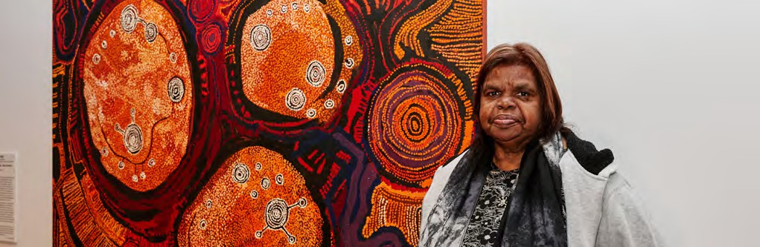

Image: Nyunmiti Burton with her work *Kungkarangkalpa – Seven Sisters* at *Kungka Kunpu (Strong Women)* exhibition opening, Geelong Gallery, 2023. Photo: Hails and Shine.

## Governance Goal 3: Employment

|  |  |  |  |  |
| --- | --- | --- | --- | --- |
| **SHORT-TERM: develop targets and tools to ensure more inclusive employment at PGAV** | | | | |
| **Action** | **Responsibility** | **Timeline** | **Resourcing** | **Consultation** |
| Set diversity targets for Board, staff and external contractors. | Executive Officer, Board | March 2026 |  |  |
| Develop an Inclusive Hiring Checklist and protocols. | Executive Officer | June 2026 |  | AAV, DARTs, KHT, MAV |
| Develop a complaint system, integrate into contracts and socialise with board and staff. | Executive Officer | Sept - Nov 2026 |  | AAV, DARTs, KHT, MAV |
| **Outcomes**   * PGAV has targets and tools to guide employment practices. * PGAV has a complaint system in place to ensure a safe working environment. | | | | |
| **Evaluation**   * Feedback from JEDI peak bodies ensures targets and tools are relevant and effective. | | | | |
| **LONG-TERM: review inclusive employment targets for PGAV and Victoria’s public gallery sector** | | | | |
| **Action** | **Responsibility** | **Timeline** | **Resourcing** | **Consultation** |
| Review PGAV and sector employment demo-  graphics annually. | Executive Officer,  Board | June 2027 |  |  |
| Develop checklist to assist Board decision  making moving from targets to quotas. | Executive Officer,  Board | Sept 2027 |  | AAV, DARTs, KHT, MAV |
| If required, set quotas and protocols to  achieve them. | Executive Officer,  Board | June 2028 |  |  |
| **Outcomes**   * PGAV is keeping track of its employment targets, and diversity of employment across the sector. * PGAV is responsive to complaints and implements change in its HR systems. * PGAV is proactive in its employment targets/quotas. * PGAV is tracking sector employee demographics. | | | | |
| **Evaluation**   * % of candidates applying for roles at PGAV are diversifying over time. * % of candidates from diverse backgrounds are securing roles at PGAV and in the sector (monitor through internal PGAV sys-   tems and Members Survey). | | | | |

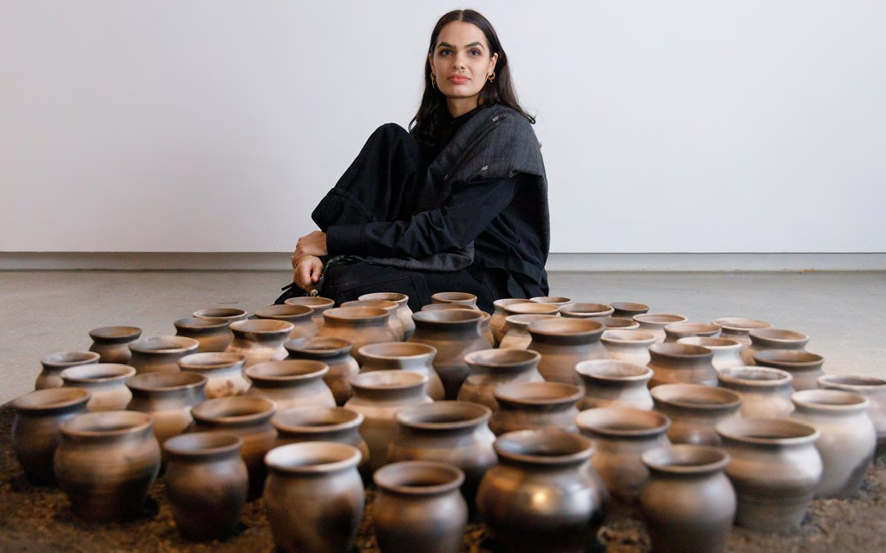

Image: Sancintya Mohini Simpson, *An ocean* 2023, installation view with artist, *TarraWarra Biennial 2023: ua usiusi faʻavaʻasavili*, curated by Dr Léuli Eshrāghi, TarraWarra Museum of Art, 2023. Courtesy of the artist and Milani Gallery, Brisbane. Photo: James Henry.

## CAPACITY BUILDING: training and programming Capacity Building Goal 1: Training

|  |  |  |  |  |
| --- | --- | --- | --- | --- |
| **SHORT-TERM: Scope and plan JEDI training for PGAV Board and Victoria’s public gallery sector** | | | | |
| **Action** | **Responsibility** | **Timeline** | **Resourcing** | **Consultation** |
| Audit Board and sector to identify JEDI train- ing needs. | Executive Officer | March 2025 |  |  |
| Consult to identify appropriate trainers and scope costs. | Executive Offi- cer, Industry Dev Officer | June 2025 | Industry Dev Officer $80k annually | AAV, DARTs, KHT, MAV |
| Begin planning training program for delivery in subsequent years. | Executive Officer | Sept 2025 |  |  |
| **Outcomes**   * JEDI training needs for PGAV and sector identified. * Appropriate trainers identified and engaged. * Work started on tailoring training needs, timing and budgeting for following years. | | | | |
| **Evaluation**   * Seek feedback from board and members about the proposed training program. * Measure program against initial expectations. | | | | |
| **LONG-TERM: Deliver JEDI training for PGAV Board and Victoria’s public gallery sector** | | | | |
| **Action** | **Responsibility** | **Timeline** | **Resourcing** | **Consultation** |
| Integrate training into annual program. | Industry Dev  Officer | Sept 2026 |  |  |
| Deliver training and undertake evaluation at  completion. | Industry Dev  Officer | Mar – Nov  2026 | Trainer costs (?) |  |
| In response to evaluation, seek advice from  experts on ways to improve training. | Industry Dev  Officer | March 2027 |  | JEDI trainers, AAV,  DARTs, KHT, MAV |
| Integrate advice into future training. | Industry Dev  Officer | August 2027 |  |  |
| **Outcomes**   * Training program is well received by the sector. * Sector is putting training into action. * PGAV is delivering on training KPIs. * Training program is being revised in response to evaluation and as needs change over time. | | | | |
| **Evaluation**   * Survey participants after each session – measure relevance, whether gained new knowledge and likelihood of implementing at their galleries. * Follow up survey (3-6 months post training) to gather case studies, determine level of change in the sector. | | | | |

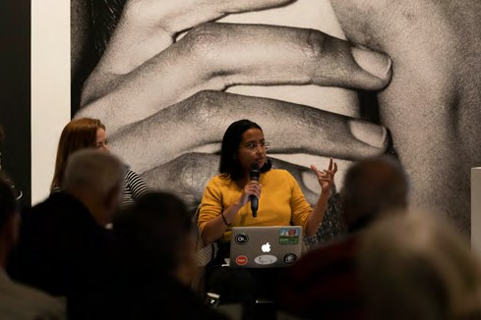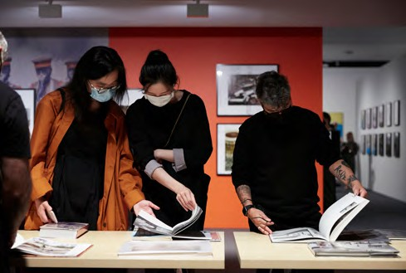

Image: Aishah Kenton speaks for *First Mondays Intro to ACTS I-VII* presented

by members of Oculi collective. Photo Sean Davey, 2022

Image: Visitors viewing photobooks at launch of *Not standing still: new approaches in documentary photography*, Museum of Australian Photography (MAPh), 2021. Photo by Zan Wimberley.

## Capacity Building Goal 2: Programming

|  |  |  |  |  |
| --- | --- | --- | --- | --- |
| **SHORT-TERM: set JEDI targets for Victoria’s public gallery sector and evaluation process to track progress** | | | | |
| **Action** | **Responsibility** | **Timeline** | **Resourcing** | **Consultation** |
| Research Victoria’s demographic data to set baseline JEDI targets. | Executive Offi- cer, Industry Dev Officer | March 2026 |  |  |
| Consult with JEDI peak bodies to set realistic targets for 2027 and 2028. | Executive Offi- cer, Industry Dev Officer | June 2026 |  | AAV, DARTs, KHT, MAV |
| Consult with members and agree to realistic targets. | Executive Offi- cer, Industry Dev Officer | Sept 2026 |  | PGAV Members |
| Establish JEDI programming questions for Member and Benchmarking surveys. | Industry Dev Officer | Nov 2026 |  |  |
| **Outcomes**   * PGAV establishes realistic JEDI programming targets for its program and for Victoria’s public gallery sector. * PGAV establishes JEDI programming targets within Membership and Benchmarking Surveys. | | | | |
| **Evaluation**   * JEDI peak bodies inform programming targets. * PGAV members agree to JEDI programming targets. * PGAV Member and Benchmarking Surveys include JEDI programming targets. | | | | |
| **LONG-TERM: undertake JEDI evaluation of Victorian’s public gallery sector and track progress over time** | | | | |
| **Action** | **Responsibility** | **Timeline** | **Resourcing** | **Consultation** |
| Undertake evaluation of JEDI programming targets of PGAV and Victoria’s public gallery  sector, annually | Industry Dev Officer | July 2027 &  July 2028 |  |  |
| Review PGAV and sector’s JEDI programming against targets. If not achieved, seek advice  on ways to improve. | Industry Dev Officer | Sept 2027 &  Sept 2028 |  | AAV, DARTs, KHT, MAV |
| Implement improvement strategies into  sector training. | Industry Dev  Officer | Oct 2027 &  Oct 2028 |  |  |
| **Outcomes**   * PGAV is capturing longitudinal JEDI programming targets within Victoria’s public gallery sector. * PGAV is demonstrating leadership in JEDI programming. * Victoria’s public gallery sector is demonstrating best practice in JEDI programming. | | | | |
| **Evaluation**   * Review Member and Benchmarking Surveys to understand best practice within Victoria’s public gallery sector. * Share survey results with JEDI peak bodies for feedback. | | | | |

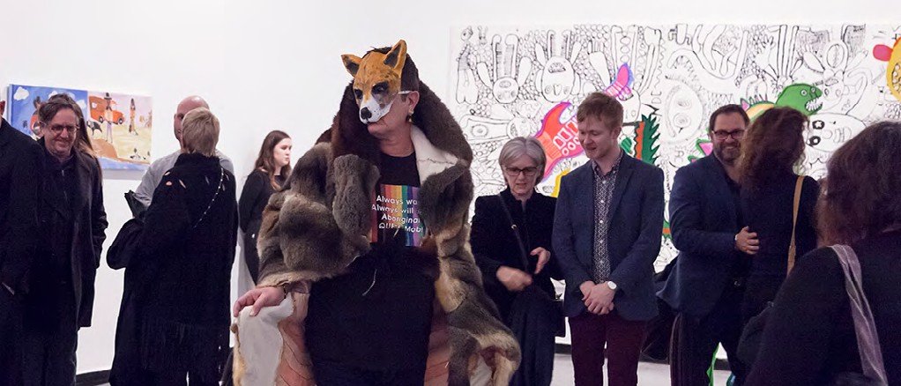

Image: Peter Waples-Crowe performance at the opening of *A Lightness of Spirit is the Measure of Happiness*

2018, Australian Centre for Contemporary Art ( ACCA). Courtesy the artist. Photograph Jacqui Shelton.

## ENGAGEMENT: community consultation, marketing and promotion Engagement Goal 1: Community consultation

|  |  |  |  |  |
| --- | --- | --- | --- | --- |
| **SHORT-TERM: audit Victoria’s public gallery sector to understand their community engagement strategies** | | | | |
| **Action** | **Responsibility** | **Timeline** | **Resourcing** | **Consultation** |
| Develop an audit tool which captures data on sector’s community engagement. | Executive Offi- cer, Industry Dev Officer | March 2027 |  | AAV, DARTs, KHT, MAV |
| Gather and evaluate responses from the sector. | Industry Dev Officer | June 2027 |  | PGAV Members |
| Develop case studies of best practice ap- proaches within the sector. Consult with JEDI peaks on how to build capacity of sector. | Industry Dev Officer | Sept 2027 |  | AAV, DARTs, KHT, MAV |
| Publish case studies on website and socials. | Comms Officer | Oct 2027 |  |  |
| **Outcomes**   * PGAV creates a series of case studies that demonstrate best practice examples from and for the sector. * PGAV has understanding of gaps in community engagement across the sector. * PGAV has identified ways to build sector capacity in community engagement. | | | | |
| **Evaluation**   * PGAV undertakes audit. * PGAV publishes case studies of sector best practice. * JEDI peaks provide feedback on sector’s community engagement practice. | | | | |
| **LONG-TERM: develop a program to build sector capacity in community engagement** | | | | |
| **Action** | **Responsibility** | **Timeline** | **Resourcing** | **Consultation** |
| Identify relevant JEDI trainers able to address gaps identified in sector community engage-  ment. | Industry Dev Officer | July 2028 |  | MRCs; CCD artists, arts workers and organisa-  tions. |
| Plan and deliver capacity building program for  sector. | Industry Dev Offi-  cer, JEDI trainers | Sept 2028 |  |  |
| Monitor impact of capacity building pro- gram over time. Consult with MRCs and CCD experts and Implement changes to program  as needed. | Industry Dev Officer | Oct 2028 |  | MRCs; CCD artists, arts workers and organisa- tions |
| **Outcomes**   * Victoria’s public gallery sector understands how to gather demographic data in a culturally safe way. * Sector knows how to undertake research into barriers for engagement within their communities. * Sector delivers programming which is informed by CALD, First Nations, LGBTIQA+, Deaf and disabled communities. * Artist and audience demographics diversify over time. | | | | |
| **Evaluation**   * Survey participants to determine if they have gained new knowledge and the likelihood of implementing in their galleries. * MRCs and CCD experts provide feedback. * Member and Benchmarking Surveys shows diversification of artist and audience demographics over time. | | | | |

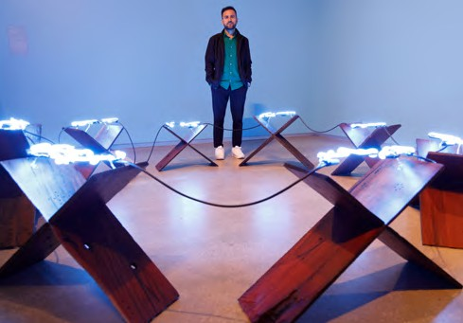

Image: Elyas Alavi with his work *Cheshme-e jaan (The Spirit Spring)*, 2023, installation view, TarraWarra Biennial 2023: *ua usiusi faʻavaʻasavili*, TarraWarra Museum of Art, 2023. Courtesy of the artist. Photo: James Henry Photography.

Image: Visitors to the exhibition *Cyrus Tang: Time Fell Asleep in the Evening Rain*, Linden New Art, 2022. Image courtesy of Linden New Art. Photo: Laura May Grogan.

## Engagement Goal 2: Marketing & Promotion

|  |  |  |  |  |
| --- | --- | --- | --- | --- |
| **SHORT-TERM: reach more diverse audiences and make PGAV communications accessible to more people** | | | | |
| **Action** | **Responsibility** | **Timeline** | **Resourcing** | **Consultation** |
| Identify demographic gaps in our audiences. | Executive Officer, Comms Officer | March 2025 |  |  |
| Identify diverse media outlets across social media, print and radio. | Comms Officer | June 2025 |  | AAV, DARTs, KHT, MAV |
| Set guidelines on when to use alt-text or descriptive text for digital media; protocols for managing social media trolls. | Comms Officer | Sept 2025 |  | AAV, DARTs, KHT, MAV |
| Identify tools to assist with accessibility for PGAV print and digital marketing and promo- tion, as well as our resources and program delivery. | Comms Officer | Oct 2025 |  | AAV, DARTs, KHT, MAV |
| Review JEDI media engagement annually | Comms Officer | 2026 onwards |  |  |
| **Outcomes**   * PGAV has a clear idea of demographic gaps in its current audience. * PGAV has guidelines and tools to address demographic gaps. * PGAV is ready to engage with diverse media and audiences. | | | | |
| **Evaluation**   * JEDI peaks provide feedback on ability of PGAV’s marketing and comms guidelines and tools to address demographic gaps. * PGAV evaluates JEDI media engagement annually. | | | | |
| **LONG-TERM: identify and support Victoria’s public galleries to follow best practice in JEDI marketing and promotion.** | | | | |
| **Action** | **Responsibility** | **Timeline** | **Resourcing** | **Consultation** |
| Consult with JEDI peaks on best practice in  marketing and promotion. | Comms Officer | March 2025 |  | AAV, DARTs, KHT, MAV. |
| Create a checklist and deliver a training session for public gallery sector on JEDI  marketing and promotion. | Comms Officer, In- dustry Dev Officer,  JEDI peaks | Sept 2025 |  | AAV, DARTs, KHT, MAV |
| Monitor sector’s progress over time. If not seeing change, promote its importance and  re-run training. | Comms Officer | July - Sept 2026 - 2028 |  |  |
| **Outcomes**   * PGAV has a checklist and delivers training session on best practice JEDI marketing and promotion. * Majority of Victoria’s public gallery sector has attended PGAV training and aware of best practice. * PGAV is monitoring diversity in sector marketing and promotion. | | | | |
| **Evaluation**   * JEDI peaks provide feedback on PGAV checklist. * Undertake survey after training session to determine if participants gained new knowledge and likelihood will implement in their galleries. * PGAV monitoring shows diversification within sectors marketing and promotion over time. | | | | |



Image: Visitors to the Art Gallery of Ballarat, viewing works from the permanent collection, 2022.

Image: Eric Nash, Benalla Art Gallery Director and curator of the *Tones of Home* exhibition speaks at the exhibition opening alongside Auslan

interpreter Stacie Van Hulst, Arts Project Australia, 2023. Photo: Janelle Low.

## DELIVERY SCHEDULE

|  |  |  |  |  |  |  |
| --- | --- | --- | --- | --- | --- | --- |
|  | **Goal** | **2025** | **2026** | **2027** | **2028** | **Who** |
| **GOVERNANCE** | **POLICY SHORT-TERM:** develop a JEDI statement or pledge | March -  June |  |  |  | EO |
| **POLICY LONG-TERM:** JEDI statement integrated into PGAV  Rules of Association |  | March -  May |  |  | EO, Board |
| **LEADERSHIP SHORT-TERM:** scope and plan a JEDI leader- ship program to increase number of diverse leaders in the  sector | March - Sept |  |  |  | EO, IDO |
| **LEADERSHIP LONG-TERM:** Deliver Leadership Program,  develop an Internship Program |  |  | March |  | EO, IDO, CO |
| **EMPLOYMENT SHORT-TERM:** develop targets and tools to  ensure more inclusive employment at PGAV |  | March -  Sept |  |  | EO, Board |
| **EMPLOYMENT LONG-TERM:** review inclusive employment  targets for PGAV and Victoria’s public gallery sector |  |  | June-  Sept | June | EO, Board |
| **CAPACITY BUILDING** | **TRAINING SHORT-TERM:** Scope and plan JEDI training for  PGAV Board and Victoria’s public gallery sector | March -  Sept |  |  |  | EO, IDO |
| **TRAINING LONG-TERM:** Deliver JEDI training for PGAV  Board and Victoria’s public gallery sector |  | March -  Nov | March -  Nov | March -  Nov | IDO |
| **PROGRAMMING SHORT-TERM:** set JEDI targets for Victo- ria’s public gallery sector and evaluation process to track  progress |  | March - Nov |  |  | EO, IDO |
| **PROGRAMMING LONG-TERM:** undertake JEDI evaluation of Victorian’s public gallery sector and track progress over  time |  |  | July - Oct | July - Oct | IDO |
| **ENGAGEMENT** | **COMMUNITY CONSULTATION SHORT-TERM:** audit Victo-  ria’s public gallery sector to understand their community  engagement strategies |  |  | March - Oct |  | EO, IDO, CO |
| **COMMUNITY CONSULTATION LONG-TERM:** develop a pro-  gram to build sector capacity in community engagement |  |  |  | July - Oct | IDO |
| **MARKETING & PROMOTION SHORT-TERM:** reach more  diverse audiences and make PGAV communications acces-  sible to more people | March - Oct |  |  |  | EO, CO |
| **MARKETING & ENGAGEMENT LONG-TERM:** identify and  support Victoria’s public galleries to follow best practice in  JEDI marketing and promotion. | March - Sept | July - Sept | July - Sept | July - Sept | CO, IDO |

**Key**

Delivery of these programs is subject to funding of Industry Development Officer position at PGAV.

Image: *Takeover at Parliament Steps*, Parliament Steps, Melbourne, as part of the *Who’s Afraid of Public Space?* program, 2022. Presented by The Social Studio, Outer Urban Projects, Youthworx in collaboration with the Australian Centre for Contemporary Art (ACCA). Photograph: Keelan O’Hehir.

PGAV MEMBERS

PGAV represents 69 public galleries across metropolitan, outer metropolitan and regional Victoria:

Art Gallery TAMA

Art Gallery of Ballarat Arts Centre Melbourne Arts Project Australia ArtSpace at Realm

Australian Centre for Contemporary Art | ACCA Australian Centre for the Moving Image | ACMI Bayside Gallery

Benalla Art Gallery Bendigo Art Gallery

Bundoora Homestead Art Centre Bunjil Place Gallery

Burrinja Cultural Centre Buxton Contemporary

Cardinia Cultural Centre Gallery Carlisle Street Arts Space Castlemaine Art Museum Central Goldfields Art Gallery City Gallery

Counihan Gallery In Brunswick Craft Victoria

CS Gallery

Deakin University Art Gallery Djaa Djuwima

Duldig Studio

East Gippsland Art Gallery

Eltham Library Community Gallery Geelong Gallery

Gippsland Art Gallery

Glen Eira City Council Gallery Grainger Museum

Hamilton Gallery

Heide Museum of Modern Art Hellenic Museum

Horsham Regional Art Gallery

Hyphen - Wodonga Library Gallery Ian Potter Museum of Art Incinerator Gallery

Jewish Museum of Australia Kingston Arts Centre Koorie Heritage Trust

La Trobe Art Institute | LAI Latrobe Regional Gallery | LRG Linden New Art

Manningham Art Gallery McClelland Sculpture Park + Gallery Mildura Arts Centre | MAC

Monash University Museum of Art | MUMA Montsalvat

Mornington Peninsula Regional Gallery | MPRG Museum of Australian Photography | MAPh National Gallery of Victoria | NGV

Old Quad

RMIT Design Hub RMIT First Site Gallery RMIT Gallery

Science Gallery Melbourne Shepparton Art Museum | SAM State Library Victoria | SLV Swan Hill Regional Art Gallery TarraWarra Museum of Art

The Dax Centre Town Hall Gallery

Victorian Artists Society Walker Street Gallery Wangaratta Art Gallery Warrnambool Art Gallery Whitehorse Art Space Wyndham Art Gallery

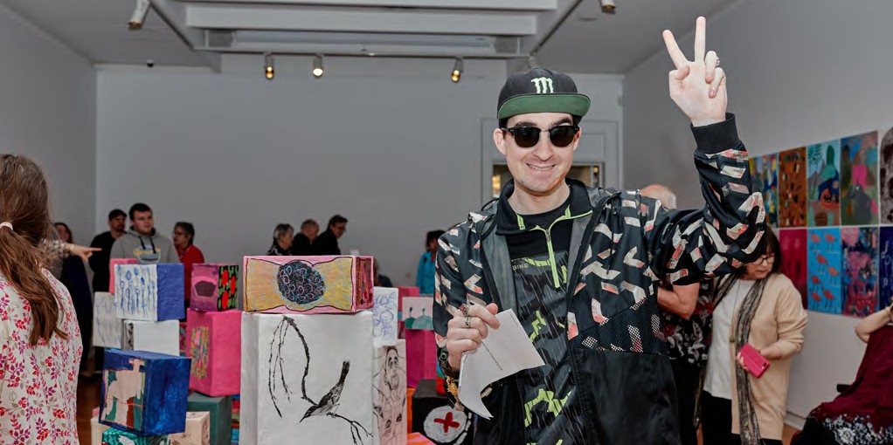

Image: Aaron Deans at the g*enU studio artists—RISE* exhibition opening, Geelong Gallery, 2023, Photo: Hails and Shine.

**Public Galleries Association** Victoria

**PG**

**A** V

LOCATION

NGV Australia Federation Square

POSTAL ADDRESS

PO Box 7259

Melbourne, Vic 8004

CONTACT

T: 0403 268 017

WEB

pgav.org.au