Regenerate | RestART | Renew

Arts based healing after the bushfire disaster

The East Gippsland Community has suffered through intense bushfires that have impacted almost the entire landscape. An area that covers 14% of the state, from the most western boarder of East Gippsland to the most eastern.

As a public gallery and as people who live in and love our community, we felt a responsibility to help the people who had suffered through these fires in any visual arts capacity that we could.

Our initial response was to engage with local Arts Therapist Andrea Farley. Andrea holds a Diploma in Arts Therapy, an Advanced Diploma of Disability, and a Diploma of Leisure Lifestyle (Diversional Therapy) and has strong relationships with communities across East Gippsland.

During our first meeting, Andrea advised the team of the many facets of arts-based therapy that can be used to heal trauma. Suggesting that an on the ground therapeutic response would be the best, and that such an approach should be delivered in two stages. The first being the immediate response and the second a long-term response.

The gallery was contacted by the Grants Manager from Gandel Philanthropy Alexandra White.

Alexandra reached out to us post bushfires to see if there was something that the Gandel organisation could do to support the area through arts-based programs.

The result was the implementation of a program that would help community members who had suffered trauma to heal. *Regenerate | RestART | Renew* is a program based around the concept that ***art is always a form of healing***.

Andrea stressed that long term programs were not needed in the immediate response, as it was too soon. What was needed were simple drop-in workshops in public spaces where anyone could create. Nothing too serious and structured, but a relaxed space where people could sit and play. She suggested that sensory based activities were best, so our new Arts Learning Coordinator Melanie Murphy and Andrea set up at the local library with a multitude of coloured play dough for four weekly sessions. Allowing people to drop in, squeeze and sculpt playdough whilst having a chat.

The long-term response would need to begin at least two months or more after the fires. This is a time when people are coming to terms with what has happened and the long road to recovery.

Bruthen, Orbost, Cann River and Mallacoota were identified as communities who had suffered the most, and so it was these locations that a series of six to seven weekly workshops would be delivered. These series of workshops are to be delivered in each location before moving to the next town. It was suggested by Andrea that other health organisations were providing programs for children and that the need for healing was greatest for adults and youth, so this program has been tailored to that demographic.

Andrea will discuss with participants the program and how learning aspects of visual arts can help individuals work through negative thoughts and emotions.

Through the teaching of art techniques Andrea and Mel will focus on building trust with participants, ensuring that everyone feels safe in a relaxed shared space, where everyone feels comfortable and can openly share their feelings and thoughts.

It is essential that participants understand that it’s not the finished piece that’s important, but rather the actual making, the process and the development of artwork in relation to personal feelings. It’s also about learning about different mediums and techniques, giving everyone the tools and knowledge to continue at home.

Meals are an integral part of each workshop. This is a time to ground participants and take a break from learning. Creating a rich nourishing safe space where hearty food is shared, and conversation is had.

Through nurturing and nourishment, Andrea, and Melanie hope to relieve participants of stress and help heal their experienced trauma.

The *Regenerate | RestART | Renew* program aims to improve the mental health and well-being of residents within the East Gippsland community that have been affected by the horrific bushfires and it is hoped that this will filter out into the broader community.

Since beginning the program, community leaders have contacted the gallery because they feel there is a need for the *Regenerate | RestART | Renew* program to be delivered in their area. So, the locations have expanded and several more areas have been added to the list of places where the arts therapy-based program will be delivered.

Andrea reports to me regularly. She has informed me that the response to this program has been incredible.

Andrea Farley’s expertise and guidance has been invaluable during the development of this program and I cannot thank her enough.



Wairewa Town Hall

The first location where *Regenerate | RestART | Renew* was delivered.

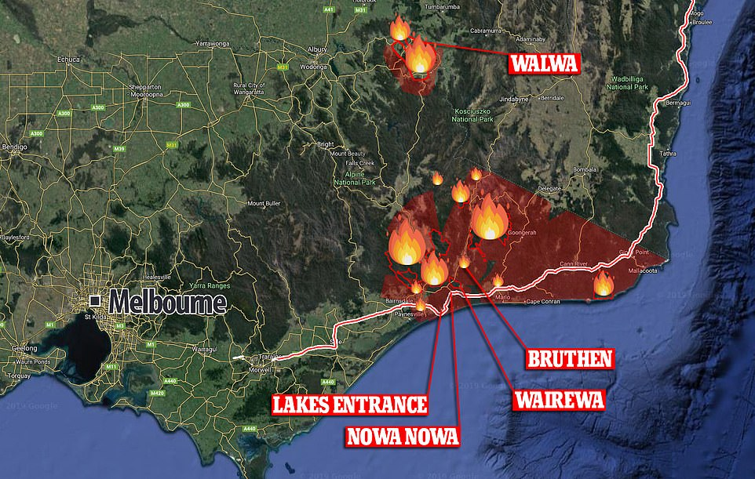

Wairewa on the map